Nathan Burlison
CS305 – Software Security
Certificate Authorities
Oct 7, 2026

A Certificate Authority, or CA, is a trusted organization responsible for issuing and managing digital certificates. Digital certificates help establish trust between a user and a website by connecting the website's identity with its public key. When a browser receives a certificate from a website, it can check whether the certificate was issued by a trusted CA. This process helps users determine whether they are communicating with the intended website rather than an attacker attempting to impersonate it. According to the National Institute of Standards and Technology (NIST), a CA is a trusted entity responsible for issuing and revoking public-key certificates (National Institute of Standards and Technology [NIST], n.d.).
One reason to use a CA is to provide authentication. Encryption can protect information while it is being transmitted, but users also need a way to determine whether they are communicating with the correct server. A certificate issued by a trusted CA provides evidence that the public key contained in the certificate is associated with the identified organization or website. This is especially important for websites that handle sensitive information, such as financial, personal, or account information.
Another advantage of using a CA is that major web browsers and operating systems already maintain lists of trusted certificate authorities. When a website presents a valid certificate that chains back to one of these trusted authorities, the browser can automatically verify the certificate. This reduces the amount of work users must perform themselves and creates a more consistent method of establishing trust across the internet. CAs can also revoke certificates when a certificate is compromised or should no longer be trusted.
For development and testing, however, purchasing or obtaining a certificate from an external CA may not always be necessary. A developer can create a self-signed certificate and effectively act as the CA for the development environment. Self-signed certificates provide many of the same technical features needed to test HTTPS, including the use of a public and private key pair, without requiring a public domain or a commercial certificate. Because the certificate is not issued by a CA already trusted by the browser, the browser will normally display a security warning. For a controlled development environment, this is expected.
Certificate Generation
For this exercise, I used Java's Keytool utility to generate an RSA public and private key pair and a self-signed certificate. Oracle describes Keytool as a utility used to manage cryptographic keys, X.509 certificates, and trusted certificates (Oracle, n.d.). The certificate was generated with a 2,048-bit RSA key and a validity period of 360 days. After creating the keystore, I exported the self-signed certificate to a CER file and used Keytool to display the certificate information.

Certificate Information Screenshot
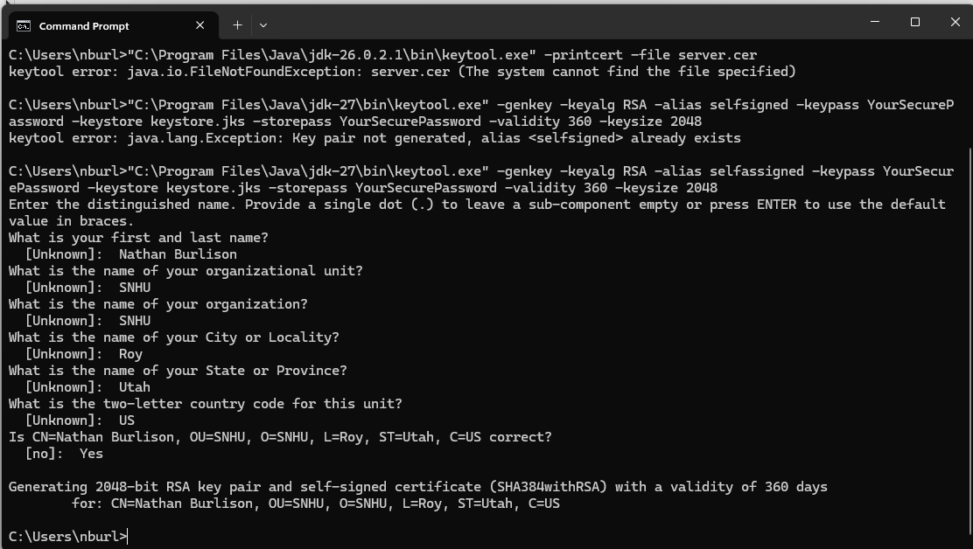
Certificate Verification Screenshot
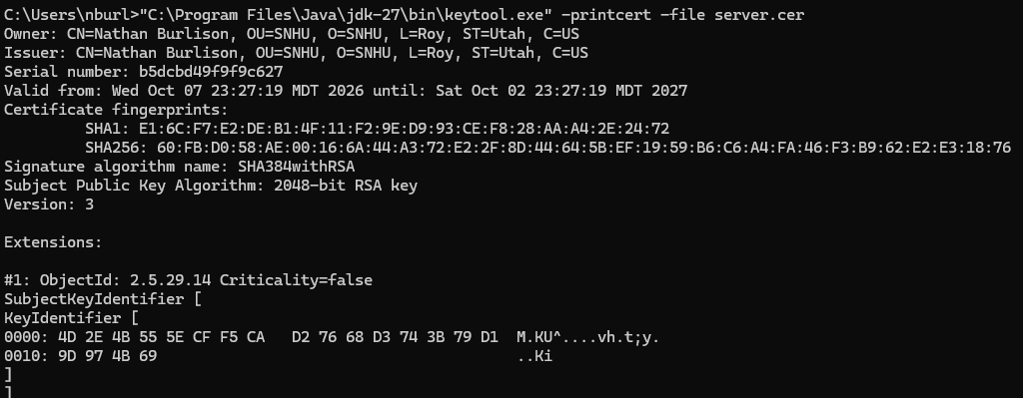

References
National Institute of Standards and Technology. (n.d.). Certification authority (CA). Computer Security Resource Center.
Oracle. (n.d.). The keytool command. Java Platform, Standard Edition documentation.

